Rutabikangwa and Nyirakamana: A Story About Domestic Violence

Questions About Rutabikangwa
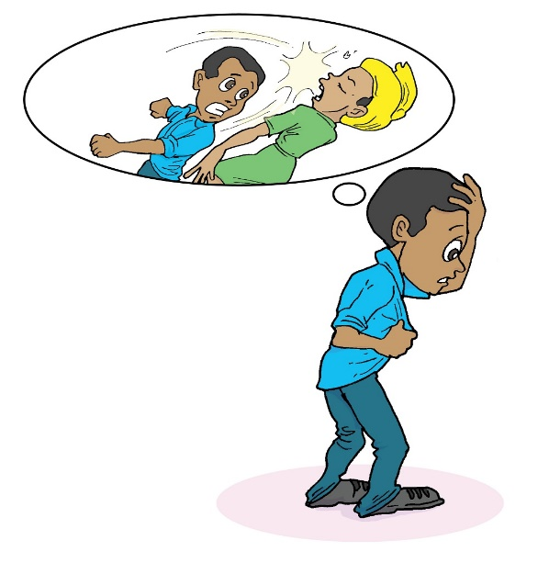
Discuss the consequences of domestic violence on Rutabikangwa:

- What are the short-term consequences for Rutabikangwa within this kind of relationship?
- What are the long-term consequences?
- How might it make him feel about himself?
- How might it make him feel about his wife, Nyirakamana?
- How might it affect their relationship?
- How might it affect his relationship with his children?
- How might it make him feel about his relationship with other people in the community?

Questions About Their Children

Discuss the consequences of domestic violence on the couple’s children:

- What are the short-term consequences for the children?
- What are the long-term consequences?
- What do children learn about relationships from watching their parents?
- How might this affect how they feel about their mother?
- How might this affect how they feel about their father?
- How might this affect the children’s relationship with other children and members of the community?
- How might this affect how the children feel in their own home?

