Title | Introducing Gender: What Makes You Proud
Objective | - Develop an awareness of the positive aspects of gender roles  - Explore the division of gender roles in society and whether they are fair
Target audience | Men and women
Group size | 20
Estimated time | 45 minutes
Materials | Flip chart, a sheet of paper and a pen for each participant
Printouts/  downloadable resources | 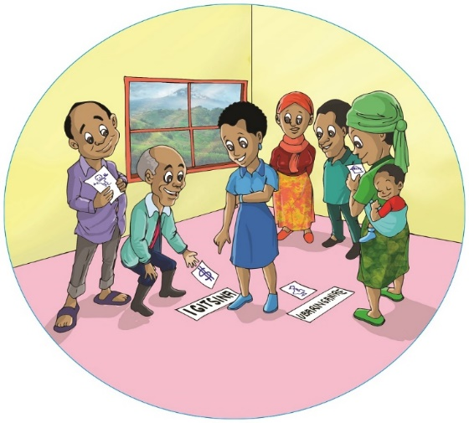
Source | Adapted from the RWAMREC training manual for Farmer Field School master trainers and facilitators on gender and GBV concepts and gender responsive agriculture, January 2016.

- Steps:

Introduction (10 minutes)
- Give every participant a pen and a piece of paper.
- Ask each participant to write or draw what makes them proud to be a man or a woman.

Whole group work (35 minutes)
- Explain the difference between sex and gender.
- Put three pieces of flip chart paper on the wall or the floor. Label one Men, one Women and one Both. These represent the things both sexes might be proud of, such as being good-looking or rich, and the other two represent things that are specific only to men or women. Go around the group and ask each participant what they wrote or drew.
- Help the participants to place their answers on one of the three pieces of flip chart paper, depending on whether what makes them proud could potentially apply to both men and women, or only to a man or a woman.
- Allow time for discussion if the group disagrees on which section to place an answer in, and explore their reasoning.
- To conclude the exercise, count up the number of responses in each section and ask participants whether this exercise has changed their thinking on gender roles, even if only a little bit.

2. Key message:

Gender and sex are two different concepts with different meanings. Sex relates to the physical and biological state of being male or female, whereas gender relates to social construct. Gender sometimes leads to discrimination between what men and women can do or be in society. When we explore this further, we find that both men and women are capable of doing many of the same things.

3. Notes for facilitators:
Sex refers to the biological characteristics of a person based on their genitalia and reproductive organs. For example, women have a vagina and men have a penis. There are other characteristics which tend to distinguish the sexes, such as women having breasts and men having facial hair, although the size and amount may vary hugely within a sex. Whatever the case, our sex is defined before we are born. It is part of our physiology.

Gender refers to the societal norms expected of a person based on their sex. For instance, the difference in the way men and women are expected to behave and dress, as well as the roles and jobs they can undertake. As gender is defined by society, it can develop and change over time. For example, it used to be the case that women could not own land, or that men would be looked down on for cooking at home. These are things that are changing alongside culture and society.

Gender roles are learned from birth. They are often reinforced by parents, teachers, peers and society. Gender roles reflect the way society is organised around us, and may vary according to age, social class and ethnic group.

Men are often responsible for activities that require physical strength, such as building houses. Because only women can bear children, many societies use this biological fact as a basis for allocating other roles, such as domestic chores and caring for children.

Alternative ways to run the workshop

If you have a big group (more then 20), you can divide participants into same-sex groups of three and ask them to come up with one or two things that they are all proud of. In the whole group work, you ask each group to share their ideas.

If you have no pen or paper available, divide the group into same-sex groups of three and ask them to develop and present a short sketch showing what makes them proud.

