Title | Power Flower | 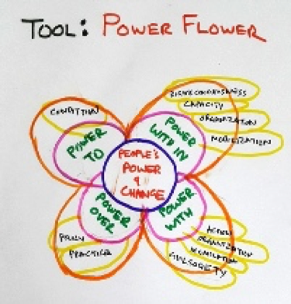  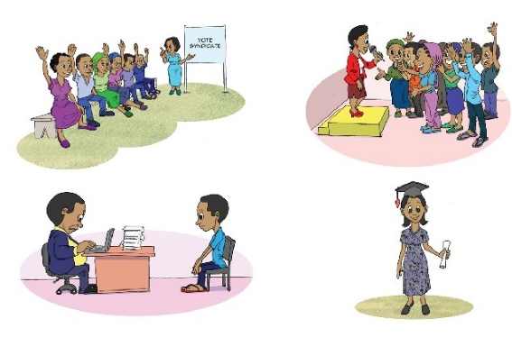
Objective | - To identify different forms of power and how they shift  - Identify strategies to use power for change
Target audience | Individuals, or groups from the same organisation
Group size | 1-8 individuals or up to 25 from the same organisation
Estimated time | 1.5 hour
Materials | Flipchart and markers for a group or sheets of paper and coloured markers for individuals
Printouts/  downloadable resources | - The four types of power
Source | Adapted from Action Aid

Power is often defined in negative terms, as a form of domination, but it can also be a positive force for individual and collective change. This exercise examines the use of positive power to promote change.

When done with individuals, this exercise is about them as a person.
When done with a group from the same organisation, this exercise is about the distribution of power within that organisation.

1. Steps:

Introduction (15 minutes)

- Show participants the image with the four types of power. Ask whether they can identify the four types of power within it. These are: power within, power with, power to and power over.
- Explain to the participants what each form of power means, using the definitions given in the Notes for Facilitators.
- Ask participants to offer examples of each type of power in their life, work or local community.

Small group work or individual work (15 minutes)

- Introduce the idea of the flower and its different components. Use a flipchart to draw the centre of the flower as a large circle. Draw the four petals with the different types of power around the centre.
- Give a group a large sheet of paper or give individual participants each a sheet of paper and markers.
- Ask participants to draw their own flower with the centre of the flower representing the individual or the organisation.
- Take one petal at a time and ask the individuals or the groups to discuss how this type of power changes and shifts within their organisation or their own lives.

Power within:
- What changes can you report in yourself, your self-confidence and awareness of your rights?
- How have these changes motivated you to act in new ways?
- How have these actions shifted power (even in very subtle ways)?

Power with:
- How have people worked together towards change?
- How have traditional alliances been strengthened and new alliances been formed?
- What changes have been influenced by this collective action?
- How do those changes reflect shifts in power?

Power to:
- What actions have people taken?
- What new things have they been able to do that were not possible before?
- How do those changes reflect shifts in power?

Power over:
- What people, groups or institutions have power over you? (It may be helpful to specify the issue that you are talking about).
- What strategies can you use to try to influence other’s agendas or actions?
- What changes have you seen in the way these groups exercise their power over a specific issue?

Encourage individuals or groups think about real-life examples of power changes they have experienced. These examples can be written or drawn in new petals around the flower, so that the flower grows as they add to it. The petals can vary in size, with larger petals representing big power shifts and smaller ones representing small power shifts.

Whole group discussion (40 minutes)

- Encourage people to present their flowers and share their experiences. Ask them to explain:
- Which side of the flower is healthy (with more petals) and why?
- Which side of the flower is weak (with fewer petals) and why?
- What could make the flower healthier/stronger?
- Finally, guide a group discussion reflecting on different forms of power.

Questions to help guide discussion:
- What strategies did you use to shift power and how effective do you think they were?
- What challenges and obstacles have been overcome? Which strategies have helped you to overcome those difficulties, challenges and obstacles?
- What have we learnt about power and its uses?
Wrap up (10 minutes)

- Encourage participants to take a photograph of the flower to remember what they have discussed.
- Thank the group for sharing their experiences and encourage them to think of ways to use the information from the session to identify new strategies for building their own positive power.

2. Key message:

The power flower tool provides a simple way to gather, consolidate and analyse shifts in different forms of power.
3. Notes for facilitators:
Power within: This includes self-worth, self-confidence, inner strength, a sense of identity, and dignity. Enhancing a person’s or organisation’s ‘power within’ encourages people to aspire towards positive change. It brings about changes in personal consciousness and conscientiousness.
Power with: Refers to collaborative power and group strength, mutual support, cooperation and working together towards joint action. ‘Power with’ helps to build bridges across different interests, experiences and knowledge. It is about bringing together varying resources and strategies. It encourages changes in problem-solving by mobilising civil society.
Power to: Is the ability to act, to shape lives, decide upon actions and carry them out. ‘Power to’ is rooted in the belief that every individual has the power to make a difference. It brings about changes to the lives of those living with poverty.
Power over: Is the domination or control of one person over another, or one group over another. Actors such as the police, judges, teachers and politicians all have a certain power over people within a society. This power can be used for positive or negative change, which is why we work to influence them for the better. It brings about policy, budgetary, and implementation changes at both state and non-state levels.
Read more about the types of power.

