Izina ry’umwitozo | Ururabo rw’ububasha | 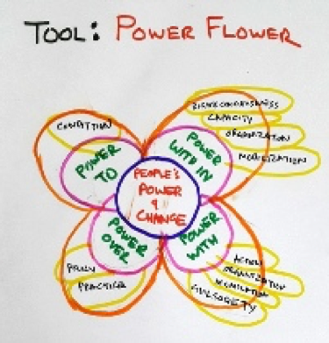  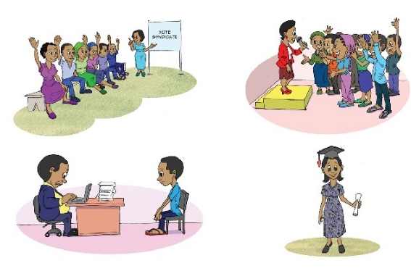
Intego y’umwitozo | - Kurebera hamwe ubwoko butandukanye bw’ ububasha n’ uko bushobora guhinduka.  - Kureba uko wakoresha ububasha mu kuzana impinduka.
Abo uyu mwihariko ugenewe | Abantu ku giti cyabo, amatsinda akorera mu kigo kimwe
Ingano y’itsinda rigenewe uyu mwitozo | Kuva ku muntu umwe kugera kubantu umunani cyangwa kugera ku bantu 25 bo mu muryango umwe
Igihe giteganijwe umwitozo ugomba kumara | Amasaha abiri
Ibikoresho | Impapuro nini na marikeri mugihe ari itsinda, impapuro zisanzwe na marikeri z’amabara ku bantu ku giti cyabo.
Izindi mfashanyigisho | - The four types of power
Aho byavuye | Byateguwe hifashishijwe Action Aid

Ububasha akenshi bukunze kumvikana nk’ijambo ribi, nko gutsikamira umuntu ariko nanone ububasha bushobora kuba bwiza ku mpinduka z’umuntu ku giti cye cyangwa izabantu benshi. Uyu mwitozo wiga ku mikoreshereze myiza y’ububasha igamije impinduka.

Nyuma yo kwiga ku bantu muri rusange, uyu mwitozo wita ku muntu ku giti cye.
Nyuma yo kwiga ku itsinda ryo mu muryango umwe, uyu mwitozo wita ku isaranganya ry’ububasha mu muryango.

1. Uko bikorwa:

Iriburiro (iminota 15)

- Ereka abahugurwa ishusho iriho amoko ane y’ububasha. Maze ubabaze niba bashobora kumenya amoko ane y’ububasha ari kuri iyo shusho, ariyo: ububasha nifitemo, ububasha hamwe, ububasha bwo n’ububasha kuri.
- Sobanurira abahugurwa ko uko buri bwoko busobanura, wifashishijwe ubusobanuro bwatanzwe mu mabwiriza agenewe umufashamyumvire.
- Saba abahugurwa gutanga ingero kuri buri bwoko bw’ububasha mu buzima bwabo bwa buri munsi, ku kazi cyangwa aho batuye uganisha ku ntego y’amahugurwa.

Umukoro wo mu matsinda cyangwa uw’umuntu ku giti cye(iminota 15)

- Basobanurire igitekerezo cy’ururabo n’ibirugize. Koresha urupapuro runini ushushanya igice cyo hagati cy’ururabo ushushanya uruziga runini. Shushanya ibindi bice bine bigize ururabo maze wandike ubwoko bune bw’ububasha iruhande rw’urwo ruziga.
- Hereza itsinda urupapuro runini cyangwa hereza urupapuro rusanzwe umuntu ku giti cye na marikeri.
- Saba abahugurwa gushushanya ururabo rufite igice cyo hagati rusobanura umuntu cyangwa umuryango runaka.
- Fata igice kimwe cy’ururabo maze ubaze abahugurwa kuganira k uburyo ubwo bwoko bw’ububasha buhinduka cyangwa bwimuka mu muryango cyangwa mu buzima bwa bwabo.

Ububasha nifitemo:
- Ni izihe mpinduka wakwibonaho wowe ubwawe, kwigirira icyizere kwawe cyangwa kumenya uburenganzira bwawe?
- Ni gute izo mpinduka zagushishikarije guhindura imyitwarire yawe?
- Ni gute ibyo bikorwa byahinduye ububasha? (N’ubwo impinduka yaba ari nto)?

Ububasha hamwe:
- Ni gute abantu bashyize hamwe ngo bagere ku mpinduka?
- Ni gute ubufatanye bwo hambere bwongerewe imbaraga kandi nanone ni gute ubufatanye bushya bwavutse?
- Ni izihe mpinduka zagezweho biturutse kuri iki gikorwa?
- Ni gute izo mpinduka zerekana iyimuka ry’ububasha.

Ububasha bwo:
- Ni ibihe bikorwa abantu bakoze?
- Ni ibihe bintu bishya byakozwe ubu mbere bitarashobokaga gukorwa?
- Ni gute izo mpinduka zerekana iyimuka ry’ububasha?

Ububasha kuri:
- Ni gute abantu, amatsinda cyangwa ibigo bagufiteho ububasha? (Byaba byiza ugaragaje ikibazo uri kuvugaho)
- Ni ubuhe buryo wakoresha kugira ngo uhindure gahunda cyangwa ibikorwa by’abandi?
- Ni izihe mpinduka wabonye mu buryo ayo matsinda akoresha ububasha bwayo ku kibazo runaka?

Shishikariza abantu cyangwa amatsinda gutekereza ku ngero zo mu buzima bwa buri munsi ku mpinduka z’ububasha baba barabonye. Izo ngero zishobora kwandikwa cyangwa gushushanywa mu bice bishya bizengurutse ururabyo kuburyo ururabyo rugenda rukura uko bagenda bongeraho ibindi bice birugize. Ibyo bice bigenda birutanwa mu ngano, ibice binini byerekana iyimuka rinini ry’ububasha naho ibice bito bikerekana iyimuka rito ry’ububasha.

Umukoro w’itsinda ryose(iminota 40)

- Kangurira abahugurwa kwerekana indabyo zabo maze banasangize abandi ubuhamya bwabo. Basabe basobanure:
- Ni uruhe ruhande rw’ururabyo rumeze neza( rufite ibice byinshi birukikije) kandi kubera iki?
- Ni uruhe ruhande rw’ururabyo rutameze neza( rudafite ibice byinshi birukikije) kandi ni kubera iki?
- Ni iki gishibora kongera ururabyo rwawe imbaraga cyangwa icyagira ururabyo rwawe neza?
- Mu gusoza yobora abahugurwa mu kiganiro bareba ubwoko bw’ububasha.

Ibibazo wakwifashisha uyobora ibiganiro:
- Ni ubuhe buryo wakoresheje wimura ububasha kandi ni gute wumva ko bwari uburyo bwiza?
- Ni izihe nzitizi cyangwa imbogamizi wahuye nazo? Ni ubuhe buryo bwiza wifashishije utsinda izo nzitizi cyangwa imbogamizi?
- Ni iki twize ku bubasha n’ikoreshwa ryabwo?

Mu gusoza (iminota 10)

- Saba abahugurwa bafotore indabyo zabo kandi ubasabe kwibuka ibyo baganiriyeho.
- Shimira itsinda k’ubw’ubuhamya batanze kandi ubashishikarize gutekereza ku buryo bakoresha amakuru bavanye mu biganiro mwagiranye kugirango babashe kubona uburyo bushya bwabo bwo kubaka ububasha bwiza.

2. Ubutumwa nyamukuru:

Ururabyo rw’ububasha ni igikoresho cyerekana uburyo bworoshye bwo kwegeranya, gushyira hamwe no kwiga ku iyimuka ry’ubwo bubasha butandukanye.

3. Amabwiriza agenewe umufashamyumvire :
Ububasha nifitemo: Aha harimo, agaciro kawe, kwigirira icyizere, imbaraga wifitemo, kumenya ibikuranga n’agaciro kawe. Kongera ububasha umuntu yifitemo cyangwa ububasha bw’ikigo bituma abantu abantu bifuza kugera ku mpinduka nziza. Bizana impinduka kandi bigatuma abantu bakanguka bakabigiraho ubumenyi
Ububasha hamwe: Bivuze ububasha bushyizwe hamwe, imbararaga z’itsinda, gushyigikirana, kwishyira hamwe no gukorera hamwe kugira ngo tugere ku gikorwa kimwe. “Ububasha hamwe”bufasha gushyiraho ikiraro ku nyungu zinyuranye, ubunararibonye n'ubumenyi bunyuranye. Ni ugushyira hamwe ubutunzi n’ingamba binyuranye. Byongera impinduka mu gukemura ibibazo hifashishijwe gukangura imiryango.
Ububasha bwo: Ni ubushobozi bwo gukora, guha ishusho ubuzima, gufata imyanzuro no kuyishyira mu bukorwa. “Ububasha bwo” buturuka mu kumva ko buri muntu afite ubushobozi bwo kuzana impinduka. Buzana impinduka mu buzima bw’abantu bari mubukene.
Ububasha kuri: Ni ugukandamiza cyangwa kugenga umuntu cyangwa itsinda ry’abantu. Abakozi twavuga nk’abaporisi, abacamanza, abarimu cyangwa abanyapolitike bose bafite ububasha ku muryango mugari. Ubu bubasha bushobora gukoreshwa mu kuzana impinduka nziza cyangwa mbi, ari nayo mpamvu tugira icyo dukora kugira ngo bukore bugere ku byiza. Bizana politike, igenamigambi n’ishyirwamubikorwa ry’impinduka ku rwego ry’igihugu no ku rwego rutari urw’igihugu.
Soma birambuye the types of power.

